1)

**package** secondCode;

**public** **class** App {

**private** **static** App *app*;

**private** App() {

}

**public** **static** App getInstance() {

**if**(**null**==*app*)

{

*app*=**new** App();

}

**return** *app*;

}

}

**package** secondCode;

**public** **class** Main {

**public** **static** **void** main(String[] args) {

// **TODO** Auto-generated method stub

App app=App.*getInstance*();

App app1= App.*getInstance*();

}

}

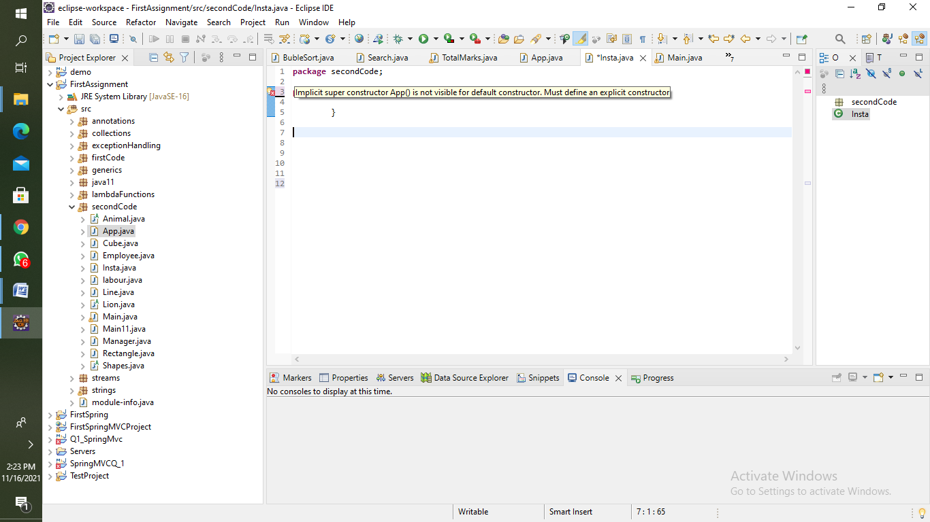

2) **package** secondCode;

**public** **class** Employee {

**int** salary;

String name;

Employee(){salary=0;

name=**null**;

}

Employee(**int** salary, String name){

**this**.salary=salary;

**this**.name=name;

}

**int** getSalary() {

**return** salary;

}

}

**package** secondCode;

**public** **class** Manager **extends** Employee {

**int** incentives;

Manager(){

**super**();

incentives=0;

}

Manager(**int** sal,String n, **int** h){

**super**(sal,n);

incentives=h;

}

**int** getSalary() {

**return** (**super**.getSalary()+incentives);

}

}

**package** secondCode;

**public** **class** labour **extends** Employee{

**int** overTime;

labour(){

**super**();

overTime=0;

}

labour(**int** sal, String n,**int** h){

**super**(sal,n);

overTime=h;

}

**int** getSalary() {

**return** (**super**.getSalary()+overTime);

}

}

**package** secondCode;

**public** **class** Main11 {

**public** **static** **void** main(String[] args) {

Manager m1 = **new** Manager(50000,"Navin",550);

System.***out***.println("Salary of Manager="+m1.getSalary());

labour l1 = **new** labour(15000,"Nikhil",550);

System.***out***.println("Salary of Labour="+l1.getSalary());

}

}

3)

Account class:

public class Accounts {

String name;

int cash;

Accounts(String name,int cash){

this.name=name;

this.cash=cash;

}

int balance() {

return cash;

}

}

Savings class:

public class savings extends Accounts {

int deposit;

savings(String n,int bal,int h){

super(n,bal);

deposit=h;

}

int balance() {

return (super.balance()+deposit);

}

}

Current class:

public class Current extends Accounts {

int cash;

Current(String n,int bal,int h){

super(n,bal);

cash=h;

}

int getSalary() {

return (super.balance()+cash);

}

}

Main class:

public class AccountMain {

public static void main(String[] args) {

savings s = new savings("Sneha",1000,5000);

System.out.println("Savings balance= "+s.balance());

Current c = new Current("Arya",0,0);

System.out.println("Current balance= "+c.balance());

}

}

4)

1.If any class has any of its abstract methods, then you must declare entire class abstract

**public** **class** Animal {

String name;

**int** age;

**float** weight;

Animal(String n,**int** a,**float** w)

{

name=n;

age=a;

weight=w;

}

**abstract** **public** **void** eat();

**abstract** **public** **void** sleep();

**public** **static** **void** main(String[] args) {

}

}

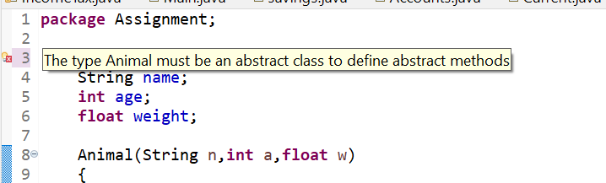

2. Abstract class cannot be instantiated

**abstract** **public** **class** Animal {

**abstract** **public** **void** eat();

**public** **static** **void** main(String[] args) {

Animal animal= **new** Animal();

animal.eat();

}

}

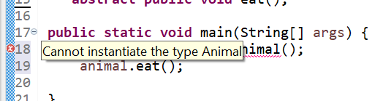

3. When we extend abstract class, we must override all the methods of abstract class in sub class or declare subclasses as abstract

**public** **class** Lion **extends** Animal {

Lion(String n, **int** a, **float** w) {

**super**(n, a, w);

}

**public** **void** eat() {

System.***out***.println("eating..");

}

}

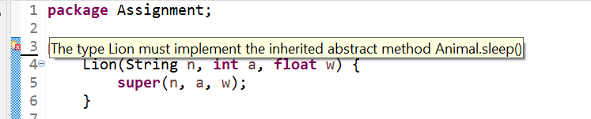

4. Abstract class cannot be private

**private** **abstract** **public** **class** Animal {

}

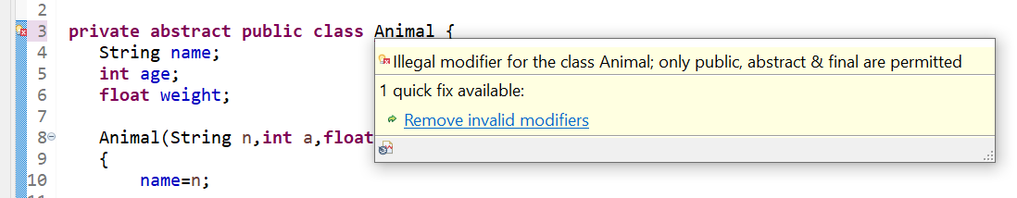

5. Abstract class cannot be final

**final** **abstract** **public** **class** Animal {

}

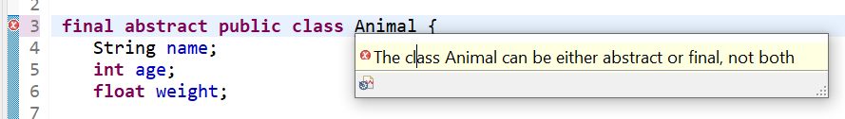

6.You can have an Abstract class without any abstract method

**abstract** **public** **class** Animal {

**public** **void** eat() {

}

}

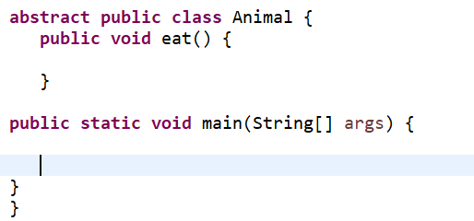

5) **package** secondCode;

**public** **class** Line **extends** Shapes {

@Override

**void** draw() {

System.***out***.println("It has 2 points");

}

}

**package** secondCode;

**public** **class** Rectangle **extends** Shapes {

@Override

**void** draw() {

System.***out***.println("It has 4 sides");

}

}

**package** secondCode;

**public** **class** Cube **extends** Shapes{

@Override

**void** draw() {

System.***out***.println("It has 6 faces");

}

}

**package** secondCode;

**abstract** **public** **class** Shapes {

**abstract** **void** draw();

**public** **static** **void** main(String args[]) {

Line l=**new** Line();

l.draw();

Rectangle r= **new** Rectangle();

r.draw();

Cube c=**new** Cube();

c.draw();

}

}